Dora Bilington: From Arts and Crafts to Studio Pottery

Marshall Coleman

Abstract
This article traces Dora Billington’s career before 1945. Although her achievements as a pottery teacher at the Central School of Arts and Crafts in the 1950s are familiar, her early years at the Central, and as a student and teacher at the Royal College of Art, have received less attention. The narrative identifies the influence of Alfred and Louise Powell on her work, and the change in the late 1920s from pottery teaching in the Arts and Crafts style to teaching inspired by studio pottery. I argue that Billington had more respect for Anglo-Oriental pottery than is often supposed and less interest in the pottery of Stoke-on-Trent.

Key Words
Dora Billington; Royal College of Art; Alfred and Louise Powell; Central School of Arts and Crafts.

Introduction
Dora Billington (1890-1968) is one of the major figures in British studio pottery in the mid twentieth century, but although her contribution in the post-war years has been well recorded, details of her career before 1945 are sketchy. She began teaching at the Royal College of Art (RCA) in 1915 and continued teaching and writing until the early nineteen sixties. Most accounts of her life depend on two sources: an interview she gave to John Farleigh in 1950 and the obituary of her in Pottery Quarterly by her colleague and friend Gilbert Harding Green; although Alison Britton’s account, the most detailed and useful, also makes use of the archives of the Central School of Arts and Crafts. As Tanya Harrod has observed, Billington is one of several key women in British crafts whose life is under-documented.

Her life is actually rather difficult to investigate: there is no archive, few papers and little correspondence. Her writing reveals little of herself. She was single and left most of her estate to Harding Green; all that remains is a few books, some notes and a collection of her pottery. However, from the exploration of archives and from interviews with people who knew her, it has been possible to construct a narrative of her early career.

Stoke on Trent

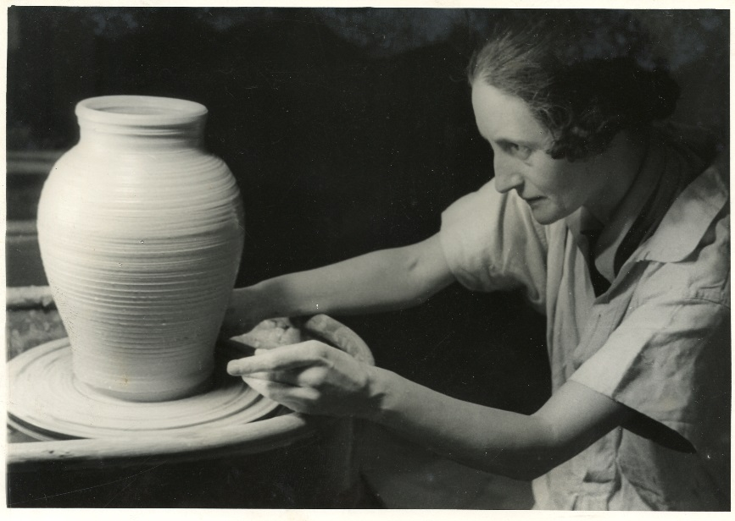
Fig. 1. Dora Billington, c.1937, a photograph taken for The Art of the Potter.
Dora Billington was born in Tunstall, an outlying town in Stoke-on-Trent, into a family of potters. Her grandfather and father ran small businesses where pots were bought in and decorated. They worked at the risky end of the trade where under-capitalised firms tried to create a niche for themselves in a volatile market. Her father was not prosperous and went bankrupt in 1912. She left school at thirteen and, as was the practice at that date, went straight into teacher training. From 1905 to 1910 she attended Tunstall School of Art as a student and pupil teacher, indicating an early choice of profession. In 1910, she transferred to the larger art school at Hanley, where she studied for two years. In her final year there she worked as a teaching assistant, partly perhaps because of her father's bankruptcy.

The Hanley curriculum consisted of drawing and painting, woodcarving, metalwork, pottery and the history and theory of design. Pottery teaching was perfunctory and the Stoke-on-Trent art schools did not offer anything like a thorough training for potters, whether industrial or artistic. That was the employers’ concern, not theirs. In 1919, government inspectors found pottery teaching at Hanley to be ‘deplorable', lacking making machines of any kind, and training in pottery in the Stoke-on-Trent art schools to be wholly inadequate.

Billington received more practical instruction from Bernard Moore, for whom she worked two days a week while at Hanley. She judged her time with him to be valuable but limited. Moore, a renowned ceramic chemist, made art wares using reduced lustre and flambé glazes, which he had been experimenting with for some years before applying the results to his own work. His factory was, in effect, a studio with a small group of painters who decorated blanks made elsewhere. In addition to the permanent staff, he took on promising students, including John Adams (later of Poole Pottery), Reginald Tomlinson (later schools art inspector for the London County Council) and Dora Billington. Several of Billington’s pieces for Moore survive, and the Victoria and Albert Museum has a fine, tall vase (Fig. 2) whose decoration shows a well-judged arrangement of a dragon motif on a Chinese-inspired form, an assured handing of the brush and the beginnings of the calligraphic style of decoration that was to be a theme in her work.

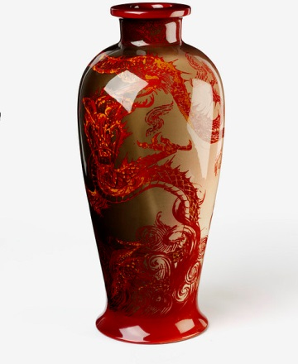
Fig. 2. Dora Billington. Vase painted for Bernard Moore, c1910. Height 45.7cm, diameter 20.3cm. ©Victoria and Albert Museum, London

Royal College of Art
At this stage in her life, she regarded pottery as ‘just trade’, with little artistic potential, and her ambition was to be a ‘real artist’, by which she meant a painter or sculptor. In 1912, she entered the RCA on a scholarship and was directed into the school of design, where W.R.Lethaby, noting that she had come from the Potteries, encouraged her to enter Richard Lunn’s pottery class. Her instructors were Lethaby, the embroiderer Grace Christie, the calligrapher Edward Johnston and Lunn.

Grace Christie practiced the kind of freehand embroidery that William Morris had advocated. Her practical guide, Samplers and Stitches, which included a picture of Billington’s embroidery, ‘The Park’ (Fig. 3), remained in print until the nineteen eighties and is still read by enthusiasts. Billington described it as 'a book that contains all that was best in the old work, adapted to modern uses', a statement that may be said to summarise her own cautious encouragement of innovation. Billington was a skilled amateur embroiderer and occasionally wrote on textile art.

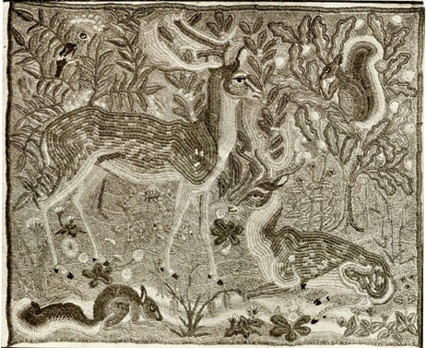
Fig. 3. Dora Billington, ‘The Park’, an embroidery made in Grace Christie’s class at the Royal College of Art, c.1914. Billington kept it and left it to Gilbert Harding Green but its present whereabouts are unknown.

Johnston’s teaching of calligraphy influenced arts other than writing and Billington’s studies with him informed her approach to ceramic decoration. The importance of free brush work was a theme to which she often returned: in the 1920s she offered decorating hints on 'the use of a long, soft, flexible brush in painting ornament swiftly and directly'; in the 1930s she praised the pottery painting of Alfred Powell, Louise Powell, Vanessa Bell and Duncan Grant and saw in Bernard Leach’s work the same ‘magic calligraphy’ as could be found on the old pottery of the Far East; and in the 1950s she encouraged the kind of ‘spirited calligraphic brushwork’ to be found on T’ang and Sung pots’.

An inscribed tin-glazed dish of uncertain date, ‘The Crowing Cock’, illustrates Billington's debt to Johnston. (Fig. 4) The lively drawing in blue and green is accompanied by refined Roman capitals around the rim. There is confidence in in the brush work, the inscription and the design, which refers to Delft ware without directly copying it. There is little comparable calligraphy on her pottery, but her lettering on this piece is so good that it is surprising that she did not do more of it, and it could be argued that she was more talented as a decorator than a maker.

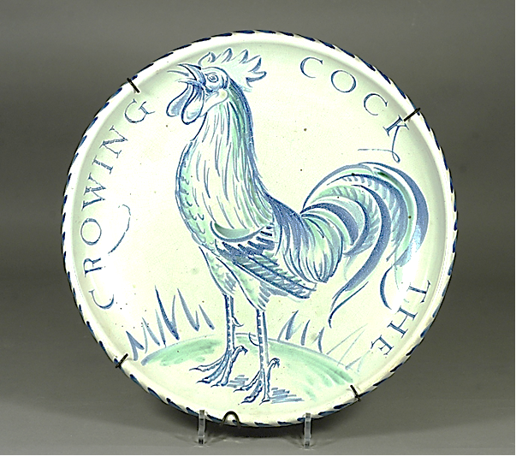
Fig. 4. 'The Crowing Cock', a tin-glazed plate by Dora Billington. Diameter 37cm. (Private collection. Photo by the author.)

Richard Lunn (Fig. 5) had been appointed pottery instructor at the RCA at the end of a long career in which he had worked on the ceramic staircase at the Victoria and Albert Museum, taught modelling at Sheffield School of Art, been art director of Royal Crown Derby pottery and run his own pottery firm. He said his course at the RCA was the first where students could make, fire and decorate their own work, and he was pivotal in the dissemination of pottery teaching in art schools, which in 1901 was almost unknown. Lunn also began a course at Camberwell School of Arts and Crafts in 1908, and by 1910 there were several courses in London, most of whose instructors he had trained.

His syllabus at the RCA comprised tile-making, mould-making, use of the jigger and jolley, glazing, decorating, and firing bisque, glaze and enamel kilns. Lunn could not throw on the wheel and throwing was not taught. His models were mainly sixteenth and seventeenth century pottery, in particular decorated Persian, Iznik and Italian maiolica, which was the sort of pottery his students made. (Figure 6) Despite Lunn’s long experience, there are indications that his teaching was inadequate: one reviewer of his book Pottery thought his methods were outmoded, and John Adams complained that Lunn had no technical knowledge of reduced lustre and that he obstructed Adams’s attempts to make it. In his final years his daughter Dora Lunn was afraid he would be dismissed because of his age.

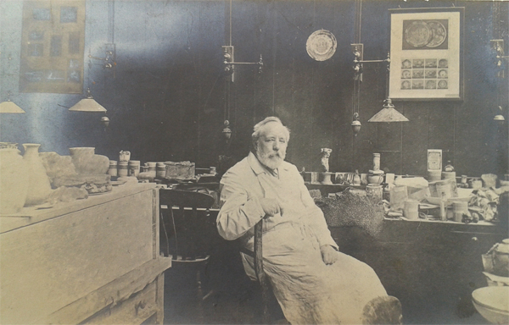
Fig. 5. Richard Lunn in his studio at the Royal College of Art, c. 1910, aged about seventy. On the crowded bench are the plaster moulds that were the mainstay of pottery-making in his class, and on the wall are specimens of decorated Middle Eastern and Italian pottery. (Victoria and Albert Museum, Archive of Art and Design, AAD1/157 1983)

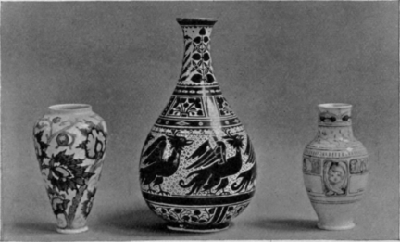
Figure 6. Student work designed and made in Richard Lunn's class at the Royal College of Art.

Billington joined Lunn's class in 1914 and studied with him for only two terms before he died. Although she acknowledged her debt to Moore, she never mentioned Lunn in writing, which may lead us to suppose that, of all her teachers, he had the least influence on her, but she shared his high regard for the painted pottery of Italy and the Middle East. She rated Persian lustre highly and admired the skill of the maiolica painters. Shortly after Lunn’s death, she and Adams were asked to take over his class. When Adams left for South Africa, Billington, then aged twenty-five and yet to complete her diploma course, was put in charge.

A set of cups and saucers that she made at the time indicates the sort of pottery she learned from Lunn. They appear to have been made in moulds and were decorated in alternate rows of blue bands and lustre motifs applied with a few deft strokes. (Fig. 7) In 1916, Lethaby wrote in her student report that she had made 'a tea set good in design’, adding the comment, ‘Very able woman.’

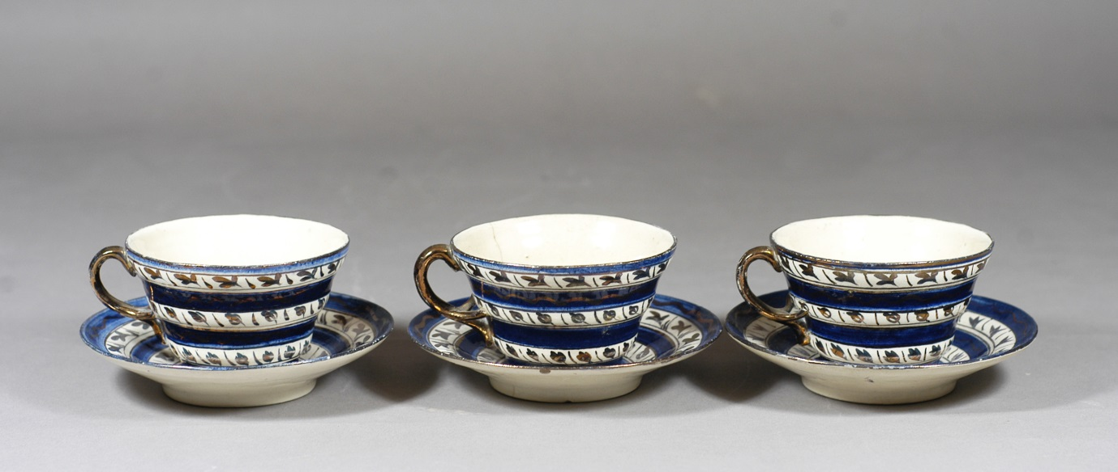
Fig. 7. Three teacups and saucers signed on the base with Dora Billington's initials, made at the Royal College of Art in 1916. (Private Collection. Photo by the author.)

In 1919, she began to teach at the Central as well as the RCA. Her RCA contract ended in 1925 when William Staite Murray was appointed pottery instructor. The circumstances of Staite Murray’s appointment, and the ill-feeling that arose between him and Bernard Leach as a consequence, are well-known. However, the circumstances of Billington’s departure from the RCA are less familiar. Her explanation, which she gave to Farleigh twenty-five years later, was that,

When Professor Rothenstein became Principal of the College, he felt that the junior staff should not stay beyond a certain number of years, and we were all informed that we should not be kept on.

That is not entirely convincing. William Rothenstein had been appointed in 1920 and Billington did not leave for another five years. In 1925, she was thirty-five and had been teaching at the RCA for ten years, so she was hardly ‘junior’. The explanation is more likely to be found in the new policies that Rothenstein had introduced to the College. He had been hired to improve the reputation of the RCA, which was poor. He thought that what it needed was not full-time, professional teachers but practicing artists of distinction who should have studios in the College and who would teach by example.

He supported Billington’s expansion of the pottery class and her acquisition of throwing wheels and a high-temperature kiln. As a result of her efforts, the course was awarded Grand Prix in Technical Instruction at the 1925 Paris Exposition des Arts Décoratifs et Industriels. Why, then, despite his initial support and Billington’s undoubted achievements, did Rothenstein appoint Staite Murray in her place? He was unimpressed by much of the work being done in the design department, including that in her class:

Much of the work in the Schools of Pottery, of Painting and Decorating and of Metalwork is too unexperimental and derivative. No consistent attempt appears to have been made to deal with the interpretation of the contemporary world in design and execution. A wrong understanding of the spirit which made mediaeval art so vital persists at Kensington, and the research work towards the discovery of new subject matter and new treatment, so noticeable on the Continent, seem to have been wanting.

At first, he thought that she might be assisted by visits from Alfred and Louise Powell, the ‘ablest and most scholarly pottery painters’ he knew. But that was in 1920. By 1924, Staite Murray had emerged as the leading exponent of the new studio pottery, and although Billington had exhibited and won international prizes, she lacked Murray’s reputation. She was primarily a teacher, she did not have her own studio and she was still working in the Arts and Crafts manner. The explanation that she was given, that junior staff 'should not stay beyond a certain number of years', was probably Rothenstein’s diplomatic gloss on sacking her.

Billington was arguably a better teacher than Staite Murray, who said 'A Zen master teaches by not-teaching'. Some of his students said they received no instruction from him at all, and when Robert Baker took over ceramics after the Second World War he found a locked room full of equipment that had been put there to stop students using it. Staite Murray was a charismatic presence and influenced many potters (including Sam Haile, Henry Hammond, Heber Mathews, Robert Washington and Ursula Mommens) but some had to take evening classes at the Central with Billington to learn how to actually make pots and glaze them. Despite this, she wrote admiringly of Staite Murray, 'whose magnificent big pots with their interesting mysterious surface-treatments reach out to possibilities as yet unexplored,' and invited him to teach at the Central.

Central School of Arts and Crafts
Ceramics had been introduced to the Central in 1906 with a class in pottery decoration taught by Alfred Powell. Powell advocated freehand painting rather than the cheap filling-in of transfers that had become increasingly common in Stoke-on-Trent and which he thought demoralised the decorators. He said:

[W]e put little girls – susceptible to the usual delights of childhood, to sit in factories day after day placing little dabs of green and red on printed patterns until they turn into automatons.

A few years earlier, he had begun designing pottery for Wedgwood, which was to be painted freehand in Wedgwood’s Etruria factory and in a studio in London where Powell and his wife Louise were to work with a few assistants. The Powells continued working for Wedgwood in this way, wedding Arts and Crafts principles and methods to factory production, until the Second World War. Maureen Batkin has observed that the Central 'exercised a considerable influence over the development of the Powells’ studio and that many of the arts and crafts designers drawn to it were either students or teachers at the Central;' the influence went the other way as well, as the Powells’ work bore heavily on what was taught at the Central.

The 1908 prospectus recorded:

A class in China Painting, including design, is conducted by Miss M. Hindshaw on Tuesdays and Thursdays from 7 p.m. to 9.30 p.m. and comprises the following processes: Painting in underglaze, hardening, glazing, firing; painting on overglaze or enamel colours; tiles; majolica. The attention of designers wishing to get in touch with a craft is directed to the facilities thus offered for turning their designs to practical account.

Maggie Hindshaw was one of the Powells’ assistants in their Red Lion Square studio, which was a stone’s throw from the Central. She taught their style and method, which can be discerned in her students’ tight, floriated decorations. (Figs. 8 and 9) A jar Billington made in 1923, painted with controlled and repeated leaf motifs, also has affinities with the Powells’ work, though it displays rather more independence. (Fig. 10)

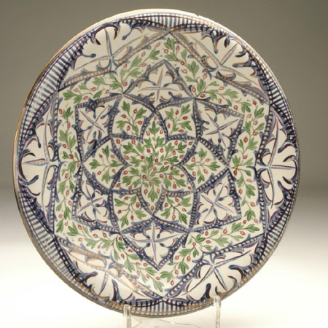
Fig. 8. Louise Powell, plate in white earthenware with hand-painted under-glaze leaf and frond decoration in red, green and pink lustre, c.1928 Diameter 31 cm. © Aberystwyth University Ceramics Collection and Archive.
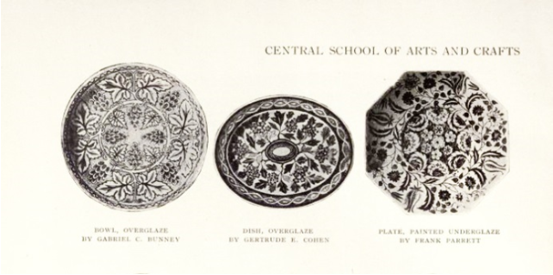
Fig. 9. Pottery decorated by Maggie Hindshaw's students at the Central (1916) showing the influence of the Powells.

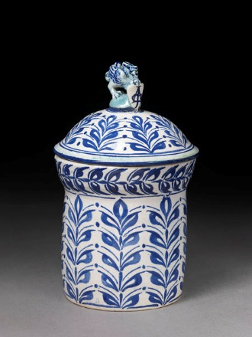
Fig. 10. Dora Billington, jar, tin glaze on a cream body, 1923. Height 23 cm. Its decoration in blue and green with repeat motifs has affinities with the Powells’ work. The finial on the lid bears a monogram ‘ABJ’ and a label on the base says ‘Replica’. ©Victoria and Albert Museum, London.

The Central did not introduce pottery making until 1916 when it employed William Askew, a thrower from Doulton’s. (Camberwell’s throwing teachers, Henry and Alfred Hopkins, also came from Doulton’s.) As the Central had been set up to provide training for the crafts and trades, one might have expected throwing to have been taught earlier, but the Powells’ approach to pottery did not demand it and there were few pottery teachers available. After the First World War, the course was expanded again, and it now offered the full range of pottery techniques: ‘Throwing and turning, mould-making, pressing and casting, jigger and jolly work. Modelling and tile making. Use of slips, glazes, under-glaze, majolica and enamel colours. Firing, biscuit glaze and enamel.’ This required the employment of more staff, hence Billington’s appointment. She started as a teacher of modelling and then took over throwing in 1924, when Askew retired. She also gave lectures in ceramic history, making methods and chemistry.

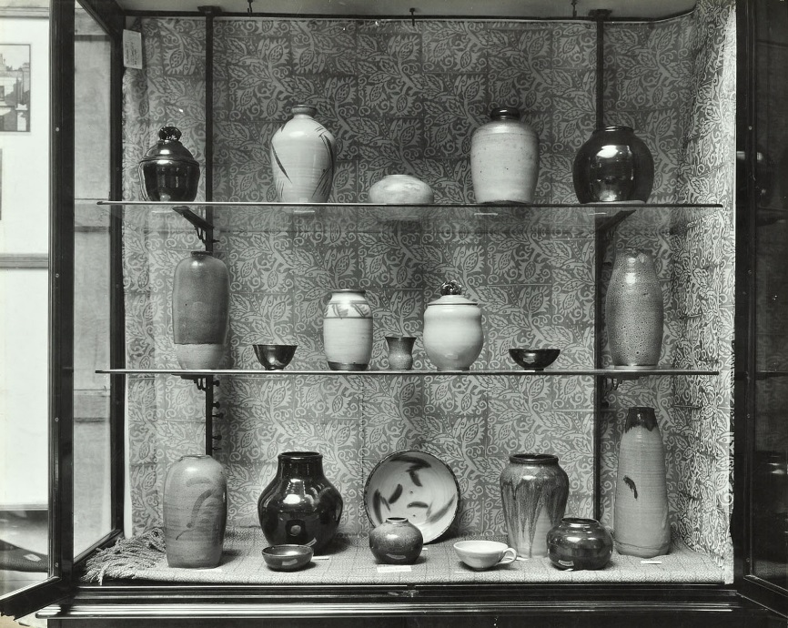
Fig. 11. An exhibit of student work at the Central School of Arts and Crafts, 1931, made in stoneware with reduced glazes. © London Metropolitan Archive.

Until 1938, Billington was merely Hindshaw’s assistant, but her influence was considerable, and the college principal, F.V.Burridge, recorded that a good deal of the success of the class had been due to her. Leach, Cardew and Staite Murray had opened her eyes to the possibilities of a new sort of pottery, and within a few years of her leaving the RCA she had transformed student work at the Central. A high temperature kiln was installed in about 1927 and in 1931 an exhibit of student work was dominated by vigorously thrown stoneware vessels. (Fig. 11) The Studio observed, ‘It is inevitable, perhaps, that the younger generation should be influenced by the work of Mr. Bernard Leach and Mr. W. Staite Murray, but there is little evidence of plagiarism.’

Ironically, Murray’s influence at the RCA was not fully felt until about this time, and some of his students continued to make painted tiles and 'faience decorations' for several years after his arrival.

Ambivalence about Industry
Billington’s little book The Art of the Potter (1937) contained within a small space both historical and practical information and an account of current trends in studio pottery. In it she said that she could not help feeling that all pottery, whether of the factory or the studio, was one, but her attitude to factory made pottery was ambivalent and her interest in it may have been overstated. She was not fully familiar with industrial methods and it is unlikely that she worked for any Stoke-on-Trent factories after her departure from Moore in 1912.

The idea that she designed for industry is suggested by her freehand enamelling on plates, cups and tureens made by J. & G. Meakin, several of which are in the Victoria and Albert Museum. They were given to the V&A by the British Institute of Industrial Art and the museum describes them as ‘made by J. & G. Meakin.’ But Meakin’s business was based on high-volume production and they applied decoration only by lithography or transfer. It is doubtful that they would have commissioned anything like this that could not be made at speed. Billington showed a dinner service decorated on Meakin blanks at the Arts and Crafts Exhibition Society in 1928, without any mention of Meakin, and the Society, with its ideological commitment to the hand made at that date, would not have exhibited work made for industry. (Fig. 12)
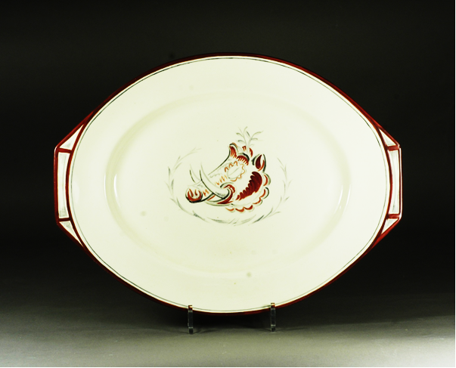
Fig. 12. Dora Billington. A serving plate painted freehand in overglaze enamels, from a 46-piece dinner service. Width 42 cm x height 31.5cm. Although J. & G. Meakin made the china, it is unlikely that they commissioned the decoration. (Private collection. Photo by the author.)

In the 1930s there were many initiatives aimed at bringing artists closer to industry. Influential thinkers like Walter Gropius and Herbert Read were questioning the relevance of the crafts and there was self-questioning in the craft community as well. Billington’s opinion that, in current economic conditions, industry and the crafts ‘must work together for the advantage of themselves and in the service of the community’ was typical of the age. It is understandable in the circumstances that she was willing to bend the Central course towards factory production, and the pottery class was equipped accordingly, but this foray into mass production was short lived and was not repeated after the war. When David Queensberry looked for instruction in industrial methods at the Central in the early 1950s, he found that neither Billington nor anyone else could provide it.

Billington’s background gave her a soft spot for the Potteries, but her attachment to it may have been like Arnold Bennett’s, stronger at a distance. Her chapter on English pottery in The Art of the Potter takes the reader up to the end of the eighteenth century, after which, she thought, little remained to be said, ‘for interest had become centred on the making on “china”.’ She worked with the Council for Art and Industry and shared the aspiration of many craftspeople at the time for some kind of rapprochement with industry, but on the craftsman’s terms. Although she embraced a wide range of making methods, including quasi-industrial ones, like casting and the jigger and jolley, she was interested in their application to studio pottery rather than to mass production.

In 1928, she began her association with the Arts and Crafts Exhibition Society. She was its secretary during the Second World War and its president from 1949 to 1953. In the 1930s it became clear to some members, Billington included, that if the Society was to survive in any form it had to confront the role of the crafts in relation to industry and the place of machinery in craft production. The Society’s 1935 exhibition introduced a section devoted to mass produced articles designed by craftsmen to demonstrate the influence the crafts could have on industry. Bernard Leach was opposed to this venture and in 1938 he resigned from the Society. Billington’s letter to him asking him to reconsider reveals her own ambivalence on the subject:

I understand your point of view, which goes deeper than any mere question of an exhibition, and appreciate your ideals perhaps a little wistfully, but with my background the industrial design problem seems to me to be too actual to be ignored. I would like the craftsman to be able to help industry without losing his independence.

Anglo-Oriental Pottery
Billington’s admiration of European and Middle Eastern pottery encourages the idea that she had little time for Anglo-Oriental pottery, but her attitude to it was subtle.

As we have seen, the ceramics of Leach, Cardew and Staite Murray influenced her teaching, and she herself made pottery in the Anglo-Oriental style – for example, a tenmoku bowl in the Hanley Museum made in the 1930s, and a tenmoku coffee set in the V&A made in 1950 with a classic reduced oil-spot glaze. But as early as 1934 she expressed reservations about the Sung standard:

Which are the most beautiful pots in the world? Although most studio potters would choose the Sung stonewares of China, yet, apart from personal preferences, such an assessment would be unfair. Each type of pottery has its own standard and limitations, and can only be judged accordingly.

In The Art of the Potter she rated Chinese pottery highly, including types that received little attention from the studio potters, such as the figurative pottery of Dehua and eighteenth century porcelain. She praised Bernard Leach for the ‘harmony of shape, size, colour and texture’ of pottery made in the old manner the Far East, and her frontispiece was one of his stoneware jars.

By the 1950s she thought that ‘stoneware had gone stale’, but she was never in any doubt about the contribution that Leach had made to good design and ‘right making’ in ceramics – nor indeed about the excellence of his brush work. However, she had come to the conclusion that the work of his imitators was pretentious and dull and she thought that Leach’s standard was too narrow. Her opinion of Leach was summed up by Robert Fournier, her assistant in the late 1940s:

She admired him as a potter but what she was against everybody imitating the Far East, and she thought this has gone too far and there’s a whole world of other pots which people are ignoring, and that got her goat really; and she made it more or less part of her life’s work to put this right a bit, to show people that there things other than Sung pots. It wasn’t even Ming pots that they admired, it was always the Sung pots! She just thought it was too narrow.

Post-War
After the war, the Central pottery class returned to a bomb-damaged building and had to be started anew. There were no tools and Fournier had to design new ones. Under her direction, he developed a range of glazes that were to be used for decades and which form the basis of her famous glaze chart. There was a sense of opportunity and hope in the post-war School. By 1951, Billington had assembled the teaching team that was to define post-war ceramics at the Central: Gilbert Harding Green, Kenneth Clark, William Newland and the country potter, Richard Bateson.

Harding Green took over as head of ceramics on Billington’s retirement in 1955. He was less cautious about new ideas than she was and many of the post-war innovations in Central ceramics were his. With the arrival of a group of new young teachers in the late ‘fifties – Gordon Baldwin, Ruth Duckworth and Ian Auld – experimentation increased, although much of Billington’s legacy remained. She was full of praise for the changes Harding Green had made.

Conclusion
Billington’s career before 1930 gives some insight into early pottery teaching, which was based on the painted pottery of the Middle East and the Mediterranean. Through her training with Bernard Moore, Edward Johnston and Richard Lunn, she learned a style of free brush decoration that she first practiced in the style of the Powells and that she championed right up to the publication of The Technique of Pottery in 1962. We may see in those early influences the root of her interest in tin glazed pottery, which was such a significant feature of the work of William Newland, Margaret Hine and Nicholas Vergette – the ‘New Look’ in British Pottery.

While at the RCA she became aware of studio pottery, but in 1925 she was overtaken by William Rothenstein’s enthusiasm for William Staite Murray, who Rothenstein thought would bring greater prestige to the College. Within a few years, she had moved the Central from teaching pottery in the Arts and Crafts style to pottery in the style of Staite Murray and Leach.

Billington remained at the centre of studio pottery. Her origins in Stoke-on-Trent have led to an over-estimation of her knowledge of and interest in mass production. Although she respected Leach’s contribution to the potter’s art, she drew upon a far wider range of ceramic traditions than he did. Her catholic taste, embracing the pottery of Europe, the Middle East and East Asia, as well as contemporary currents in art and design, enabled her to create at the Central an innovative course that produced some of the most important ceramic artists of the mid-20th century.

CHRONOLOGY
1890 | Dora Billington born in Tunstall, north Staffordshire.
1903 | Leaves elementary school at 13 and commences teacher training.
1907-10 | At Tunstall art school, where she assists as a pupil teacher.
1910-12 | At Hanley art school. Works in Bernard Moore’s studio two days a week.
1912 | Scholarship to RCA. Specialises in embroidery and pottery.
1915 | Takes over pottery class on Richard Lunn’s death.
1916 | RCA Diploma.
1919 | Teaches modelling at Central School of Arts and Crafts, assistant to Miss Hindshaw.
1924 | Teaches throwing at the Central.
1925 | Leaves RCA on William Staite Murray’s appointment. At the Paris Expo, pottery courses at RCA and Central are awarded Grand Prix for technical instruction and Billington is awarded Bronze for her stained glass ‘St Joan’.
1928 | Exhibits an enamelled dinner service on Meakin blanks at the Arts and Crafts Exhibition Society.
1937 | Publishes The Art of the Potter, based on her lectures at the Central.
1938 | Appointed head of pottery on Miss Hindshaw’s retirement. Gilbert Harding Green is appointed as her assistant.
1941-43 | Secretary of the Arts and Crafts Exhibition Society.
1949-53 | President of the Arts and Crafts Exhibition Society.
1950 | Co-opted to the council of the Crafts Centre of Great Britain.
1951 | Exhibits pottery at the Festival of Britain. Articles on pottery for the Oxford Children’s Encyclopaedia.
1955 | Retires as head of pottery at the Central but continues as a visiting lecturer.
1957 | Suffers a major stroke but continues to work on The Technique of Pottery, learning to write with her left hand.
1962 | Publishes The Technique of Pottery.
1968 | Dies on return from a holiday in Italy with Gilbert Harding Green.
1972 | The Technique of Pottery revised by John Colbeck.

Notes For example, Jeffrey Jones, Studio Pottery in Britain, 1900-2005, London, A & C Black, 2007, pp.123-132; Tanya Harrod, 'The Forgotten '50s', Crafts, no.98, May/June 1989, pp.30-33; Jeffrey Jones, ‘In Search of the Picasoettes’, Interpreting Ceramics, No. 1; Julian Stair, ‘Dora Billington’, Crafts, no.154, September/October, 1998, pp.24-25.
John Farleigh, The Creative Craftsman, London, G. Bell and Sons, 1950, pp.187-195.
Gilbert Harding Green, ‘Dora M. Billington 1890-1968’, Pottery Quarterly, vol.9, no.35, 1968, pp.95-97.
Alison Britton, ‘Central Ceramics’, in Sylvia Backemeyer (ed.) Making Their Mark, London, Herbert Press, 2000, pp.82-90.
Tanya Harrod, The Crafts in Britain in the Twentieth Century, New Haven and London, Yale University Press, 1991, p.118.
I have used the archives of Central Saint Martins, the Royal College of Art, the Board of Education, Oxford University Press and the Bernard Leach archive, the V&A archive and the records of the Arts and Crafts Exhibition Society. I am obliged to Billington’s nephew Clive Billington and her niece Mary Billington for their help and also to her students and to others who knew her, who have been generous with their time: Gordon Baldwin, Alan Caiger-Smith, Ann Clark (née Wynn Reeves), Gordon Crosby, Margaret Dell, Murray Fieldhouse and Hugh Spendlove. I would particularly like to thank Valentinos Charalambous, Billington’s student and technician from 1948 to 1951, for his hospitality in Cyprus and his detailed recall of past events. I am indebted to John Colbeck for lending me Billington’s manuscript notes for The Technique of Pottery and some of her lecture notes, to Su Lupasco Washington for showing me R.J.Washington’s notes of Billington’s chemistry lectures and to Florence Tyler of the V&A for showing me the museum’s collection of Billington’s pottery. I am also grateful for information received from those who knew Gilbert Harding Green: Alan Baxter, Gerard Brierley, Alison Britton, David Reeves, Robin Welch; and for suggestions by Paul Hughes.
London Gazette, 16 April 1912, p.2744.
RCA student record: Dora Billington. Archive of the Royal College of Art.
Ibid.
Prospectus for Season 1908-1909, County Borough of Hanley, Municipal School of Art, Science, and Technology.
Board of Education, Report of Inspection of Stoke on Trent Schools of Art, 1919. National Archives, London, ED 37/717.
John Farleigh, The Creative Craftsman, London: G. Bell and Sons, 1950, p.190.
Ibid.
RCA student record.
Mrs Archibald Christie, Samplers and Stitches: A Handbook of the Embroiderer's Art, London: B. T. Batsford, [1921].
Dora Billington, 'Modern Samplers', The Town Crier (London), vol.7, no.83, March 1928, p.87.
For example, Dora Billington, ‘Modern Samplers’; Dora Billington, ‘Contemporary Needlework Pictures’, The Studio, vol.150, no.750, September 1955, pp.65-69 .
Joanna Selborne, ‘Making an Impression’, in Sylvia Backemeyer (ed.) Making Their Mark, p.18.
Dora Billington, 'Painted Ornament', The Town Crier (London), vol. 7, no. 84, April 1928, p.127. See also Dora Billington, ‘Pottery’ in Davide C. Minter (ed.), Modern Home Crafts, London, Blackie & Son, 1934, p.73: ‘Pottery painting is a matter of swift calligraphic brushwork, and very simple yet expressive design is by the best’.
Dora Billington, The Art of the Potter, London, New York and Toronto, Oxford University Press, 1937, p.111.
Dora Billington, The Technique of Pottery, London, B.T.Batsford, 1962, p.186.
Oliver Watson, Studio Pottery, London, Phaidon, 1993, p.215.
Richard Lunn, Pottery: A Practical Hand-book for Art Teachers and Students, London: Chapman and Hall, 1903, p.ix.
In 1901, the year Lunn’s course began, the only local authorities reporting that they funded pottery teaching were Godalming, the West Riding and Longton. Board of Education, Technical Education (Application of Funds by Local Authorities), London, HMSO, 1902.
'Pottery: Some Remarks on Present-Day Teaching', The Clayworker, November 1910, p.198.
Richard Lunn, Pottery: A Hand-book of Practical Pottery for Art Teachers and Students, vol.2: Decoration of Pottery, London, Chapman and Hall, 1910. Walter Crane, Ideals in Art, London, George Bell and Sons, 1905, p.60.
The Clayworker, November 1910, p.198.
Board of Education, Rules as to exhibition of pottery by students, 1914. National Archives, London, ED 23/171.
Dora Lunn , ‘A Potter’s Pot-Pourri’, Typescript in the V&A Archive of Art and Design, AAD 1/29-1983, p.3.
Billington, The Art of the Potter, pp. 55-58.
RCA student record.
The fullest account of the so-called ‘London Affair’ is in Malcom Haslam, William Staite Murray, London, Crafts Council, 1984, pp.24-26.
Farleigh, Creative Craftsman, p. 191.
William Rothenstein, Men and Memories, vol.2, London, Faber & Faber, 1932, p.380.
Minute by Dora Billington, National Archives, ED 23/547, 16 April 192.
Letter from Gordon Forsyth to William Rothenstein, 24 April 1923, National Archives, ED/23/547. Letter from Dora Billington to Sidney Greenslade, 13 November [1924], Ealing Local History Centre, GB 1158 55. NRA 35881.
'Foreign Notes', Pottery Gazette and Glass Trades Review, 2 November 1925, p.1746.
William Rothenstein, Minute to the Secretary of the Board of Education, 1 November 1921, National Archives, ED/23/550.
William Rothenstein, Minute to Mr Micheson, Assistant Secretary, Board of Education, 21 September 1920. National Archives, London, ED 23/185. There is no evidence that the Powells were actually engaged at the RCA.
Haslam, William Staite Murray, p.63.
Graham M. McLaren, 'Shaping the Future: the Ceramics Department and industry after the Second World War', in Christopher Frayling and Claire Caterall, Design of the Times, London, Richard Dennis, 1996, p.30.
Billington, Art of the Potter, p.111.
Central School of Arts and Crafts, Report of the Advisory Council on the Work of the Session 1930-31, p.6: 'Mr Staite Murray attended a meeting and gave valuable assistance to the pottery students.' Central Saint Martin’s Archive, C607.1.
Alfred Powell, ‘New Wedgwood Pottery’, The Studio, vol.98, 1929, p.880.
Maureen Batkin, Wedgwood Ceramics, 1846-1959: A New Appraisal, London, Richard Dennis, 1982, p.143.
Central School of Arts and Crafts, Prospectus, 1908, p.23.
Charles Holme (ed.), Arts and Crafts. A Review of the Work Executed by Students of the Leading Art Schools of Great Britain and Ireland, The Studio, 1916. William T. Whiteley, ‘The Central School of Arts and Crafts’, The Studio, vol.71, no.283, September 1920, p.57.
Central School of Arts and Crafts, Prospectus, 1919-20, p.13.
Central School of Arts and Crafts, Advisory Council Minutes, 2 March 1938. Central Saint Martin’s Archive, C607.1.
Farleigh, Creative Craftsman p.190.
S.B.W., ‘Miss Sybil Finnemore’s Pottery’, The Studio, vol.95, no.418, January 1928, p.33
‘Miss Sybil Finnemore’s Pottery’, p.33.
Catalogues of exhibitions of the RCA Sketch Club, National Art Library, London.
For example, Tanya Harrod says Billington designed for industry (Crafts in Britain, p.40) and Alison Britton that she was familiar with all aspects of industrial production (’Central Ceramics’, p.83).
Victoria and Albert Museum Archives, M/1/D2668.
Bernard Hollowood, The Story of J. & G. Meakin, (n.p.), 1951, p.26. The Meakin papers in the Wedgwood archive, which might settle the question, are closed to researchers.
Arts and Crafts Exhibition Society, Catalogue of the 14th exhibition, 1928, Item 489.
Harrod, The Crafts in Britain, pp. 118-121.
Billington, Art of the Potter, p.102.
British Library Sound Archive, NLSC, Crafts Lives, David Queensberry, Tape 6 (F14378) Side B
Her niece Mary Billington thought she was glad to leave the Potteries. Conversation with the author, 1 February 1913.
Billington, The Art of the Potter, p.93.
Dora Billington, Letter to Bernard Leach, 4 September 1938. Crafts Study Centre, Bernard Leach Archive. BHL/3361.
For example, Tanya Harrod, The Crafts in Britain, p.40.
Oliver Watson says that William Newland may have made this coffee set to Billington’s design as she was by then sixty years old (Watson, Studio Pottery, p.153), but Valentinos Charalambous, her technician at the time, told me he was sure that Billington made it. (Valentinos Charalambous, Conversation with the author, 19 October 2013).
Dora Billington, ’Pottery’, in Minter, Modern Home Crafts, pp.54-5
Dora Billington, Art of the Potter, pp.63-74.
Ibid, p.111.
Dora Billington, 'The Younger English Potters', The Studio, vol.145, no.720, March 1953, p.79.
Dora Billington, ‘The New Look in British Pottery’, The Studio, vol.149, no.742, January 1955, p.18.
Robert Fournier interviewed by Hawksmoor Hughes, British Library Sound Archive, 2005, Track 1.
Robert Fournier interviewed by Hawksmoor Hughes, Tracks 1 and 2. The glaze chart is in Billington, The Technique of Pottery, pp.118-121.
Dora Billington, Letter to Valentinos Charalambous, 30 December 1965.

